No. of Pages | 3
No. of Questions | 5

Department of Computer Science and Engineering
MIDTERM EXAMINATION SUMMER 2009

CSE320: Data Communications
Total Marks: 50 Time Allowed: 70 Minutes

- Answer ALL Five (5) questions.
- Figure in bracket [] next to each question indicates marks for that question.

Question No. 1

- How do the layers of the OSI model correlate to the layers of the TCP/IP model? Draw the models. [3 marks]
- Compare Internet and Data Link Layer of the TCP/IP model in terms of PDU names, addresses used and extra information that is included in the headers/trailers of the respective PDUs. [3 marks]
- What type of destination addresses in the transport, Internet and data link layer will Host A in figure no. 1, use to communicate with the web server? Also what will change when Host is sending something to Host B. [4 marks]
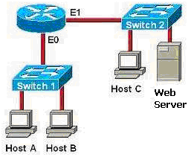
Figure 1

Question No. 2

- Name the two protocols used for emailing. Also explain why we have two separate protocols for one single application. [4 marks]
- Write down the appropriate application layer protocols that matches with the statements: [ 3 marks]
  - Assigns IP address automatically to PCs.
  - Helps you download movie files directly from another person’s PC.
  - Allows you to access a webpage after authenticated login.
  - Allows you to share files using Microsoft Operating system.
  - Converts domain names into IP addresses.
  - Used for sending emails from server to another server.
- You are requesting the web page www.bracu.ac.bd from BRACU Web Server. But the page is not being displayed in your web browser. What are the possible reasons for the web page not being displayed? State at least two reasons. [3 marks]

Question No. 3

- Host A is sending data to host B. Host A sent 3 segments of 500 bytes in size ranging from 1000 to 2499. But first two of the segments never reached host B, but the third one did. What will happen next? [4 marks]
- Host D is sending data to host E. Host E acknowledges the data but also increased the window size in the acknowledge segment. Why did host E increase the TCP window size? [3 marks]
- Name some fields that exist in TCP header but not in UDP header. [3 marks]

Question No. 4

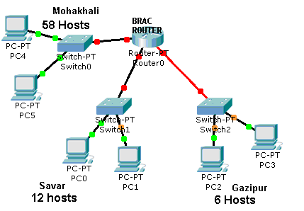
Figure No. 2
- The allocated network address for BRAC is 192.168.96.0/25. But BRAC needs separate network addresses for its offices at Savar, Mohakhali and Gazipur. How can you help?
- Note: You must subnet considering how many hosts are required for each subnet. Provide calculations and fill the table provided. [7 marks]
- Differentiate between Multicast and Broadcast IP addresses. [3 marks]

Question No. 5

This is part of a routing table.

Gateway of last resort is not set.
100.0.0.0/24 is subnetted, 2 subnets
Figure No. 3
R 100.1.1.0 [120/1] via 192.168.10.2, 00:00:02, Fastethernet0/2
R 100.1.2.0 [120/1] via 192.168.2.2, 00:00:02, Fastethernet0/1
C 192.168.1.0/24 is directly connected, FastEthernet0/0
C 192.168.2.0/24 is directly connected, FastEthernet0/1
C 192.168.10.0/24 is directly connected, FastEthernet0/2
S 110.10.10.0/24 [1/0] via 192.168.10.2

- Referring to the routing table shown above, a packet is addressed to 100.1.4.35. Will the router forward this packet? Why? [3 marks]
- Referring to the routing table in figure 3, how are the first two routes different from the last two routes of the routing table? [4 marks]
- If IP is unreliable, why is that we are always mostly successful in transmitting data using the Internet? [3 marks]

THE END

